LangGraph AI agents

Building a Dynamic Order Management System
In this extremely detailed tutorial, we’ll explore LangGraph — a powerful library for orchestrating complex, multi-step workflows with Large Language Models (LLMs) — and apply it to a common e-commerce problem statement: deciding whether to place or cancel an order based on a user’s query. By the end of this blog, you’ll understand how to:
- Set up LangGraph in a Python environment.
- Load and manage data (e.g., inventory and customers).
- Define nodes (the individual tasks in your workflow).
- Build a graph of nodes and edges, including conditional branching.
- Visualize and test the workflow.
We’ll proceed step by step, explaining every concept in detail — perfect for beginners and those looking to build dynamic or cyclical workflows using LLMs and I have also included link to the dataset for trying this out.

Table of Contents
What Is LangGraph?
The Problem Statement: Order Management
Imports Explanation
Data Loading and State Definition
Creating Tools and LLM Integration
Defining Workflow Nodes
Building the Workflow Graph
Visualizing and Testing the Workflow
Conclusion

What Is LangGraph?
LangGraph is a library that brings a graph-based approach to LangChain workflows. Traditional pipelines often move linearly from one step to another, but real-world tasks frequently require branching, conditional logic, or even loops (retrying failed steps, clarifying user input, etc.).
Key features of LangGraph:
- Nodes: Individual tasks or functions (e.g., check inventory, compute shipping).
- Edges: Define the flow of data and control between nodes. Can be conditional.
- Shared State: Each node can return data that updates a global state object, avoiding manual data passing.
- Tool Integration: Easily incorporate external tools or functions that an LLM can call.
- Human-In-The-Loop (optional): Insert nodes that require human review.

The Problem Statement: Order Management
In this scenario, a user’s query can either be about placing a new order or canceling an existing one:
- PlaceOrder: Check item availability, compute shipping, and simulate payment.
- CancelOrder: Extract an order_id and mark the order as canceled.
Because we have to branch (decide “PlaceOrder” vs. “CancelOrder”), we’ll use LangGraph to create a conditional flow:
- Categorize query.
- If PlaceOrder, move to check inventory, shipping, and payment.
- If CancelOrder, parse out order_id and call a cancellation tool.

Imports Explanation
Below is the exact first part of the code you provided, showcasing the imports and environment setup. We have added commentary after the code to explain each segment.
# Import required libraries
import os
import pandas as pd
import random
from langchain_core.tools import tool
from langchain_openai import ChatOpenAI
from langgraph.prebuilt import ToolNode
from langgraph.graph import StateGraph, MessagesState, START, END
from langchain_core.runnables.graph import MermaidDrawMethod
from IPython.display import display, Image
from typing import Literal
from langchain_core.prompts import ChatPromptTemplate
from typing import Dict, TypedDict
# Load environment variables
os.environ["OPENAI_API_KEY"] = ""
langchain_core.tools, langchain_openai, ToolNode, etc.:
- tool (a decorator) converts Python functions into “tools” an LLM can call.
- ChatOpenAI is our LLM client to talk to GPT models.
- ToolNode is a pre-built node from langgraph.prebuilt that handles tool execution.
- StateGraph, MessagesState, START, END come from langgraph.graph—they’re crucial for defining our workflow.
- MermaidDrawMethod helps visualize the workflow as a Mermaid.js diagram.

Data Loading and State Definition
Link for data: Data
In the next snippet, we load CSV files (for inventory and customers) and convert them to dictionaries. We also define our State typed dictionary.
# Load datasets
inventory_df = pd.read_csv("inventory.csv")
customers_df = pd.read_csv("customers.csv")
# Convert datasets to dictionaries
inventory = inventory_df.set_index("item_id").T.to_dict()
customers = customers_df.set_index("customer_id").T.to_dict()
class State(TypedDict):
query: str
category: str
next_node: str
item_id: str
order_status: str
cost: str
payment_status: str
location: str
quantity: int
CSV to Dictionaries:
- inventory and customers are dictionaries keyed by item_id or customer_id. This makes it easy to do lookups like inventory[item_51].
State:
- A typed dictionary so we know which fields to expect. For instance, query, category, item_id, etc.
- category is typically “PlaceOrder” or “CancelOrder.”
- next_node can store the next node name, though we rely on the graph’s edges for transitions.
- This helps keep track of everything — inventory checks, payment status, etc. — in a single object.

Creating Tools and LLM Integration
Now we define our LLM and tools. The main tool here is cancel_order, which uses the LLM to extract an order_id from the query.
@tool
def cancel_order(query: str) -> dict:
"""Simulate order cancelling"""
order_id = llm.with_structured_output(method='json_mode').invoke(f'Extract order_id from the following text in json format: {query}')['order_id']
#amount = query.get("amount")
if not order_id:
return {"error": "Missing 'order_id'."}
return {"order_status": "Order stands cancelled"}
# Initialize LLM and bind tools
llm = ChatOpenAI(model="gpt-4o-mini", temperature=0)
tools_2 = [cancel_order]
llm_with_tools_2 = llm.bind_tools(tools_2)
tool_node_2 = ToolNode(tools_2)
@tool:
- The cancel_order function is now a tool the LLM can invoke if it decides that an order cancellation is needed.
Extracting order_id:
- We call llm.with_structured_output(method='json_mode') to instruct the LLM to return JSON. Then we parse out the 'order_id'.
LLM Initialization:
- model="gpt-4o-mini" is the chosen model, with temperature=0 for deterministic responses.
Binding and ToolNode:
- llm.bind_tools(tools_2) connects our LLM with the cancel_order tool.
- ToolNode is a specialized node that can handle these bound tools automatically.

Defining Workflow Nodes
We’ll now start defining nodes one by one.



Model Call Nodes
These nodes have access to call models
def call_model_2(state: MessagesState):
"""Use the LLM to decide the next step."""
messages = state["messages"]
response = llm_with_tools_2.invoke(str(messages))
return {"messages": [response]}
def call_tools_2(state: MessagesState) -> Literal["tools_2", END]:
"""Route workflow based on tool calls."""
messages = state["messages"]
last_message = messages[-1]
if last_message.tool_calls:
return "tools_2"
return END
- call_model_2: Takes the conversation (messages) and passes it to the LLM with the bound tools. If the LLM triggers a tool call, we’ll detect that in call_tools_2.
- call_tools_2: Checks if the LLM has requested a tool call (tool_calls). If so, we route to "tools_2", which is the ToolNode; otherwise, we end the workflow.

Categorize Query
Here, we define a node for categorizing the query:
def categorize_query(state: MessagesState) -> MessagesState:
"""Categorize user query into PlaceOrder or CancelOrder"""
prompt = ChatPromptTemplate.from_template(
"Categorize user query into PlaceOrder or CancelOrder"
"Respond with either 'PlaceOrder', 'CancelOrder' Query: {state}"
)
chain = prompt | ChatOpenAI(temperature=0)
category = chain.invoke({"state": state}).content
return {"query":state,"category": category}
- This node uses the LLM to classify the user’s query. The return value sets "category" in the state.

Check Inventory
def check_inventory(state: MessagesState) -> MessagesState:
"""Check if the requested item is in stock."""
item_id = llm.with_structured_output(method='json_mode').invoke(f'Extract item_id from the following text in json format: {state}')['item_id']
quantity = llm.with_structured_output(method='json_mode').invoke(f'Extract quantity from the following text in json format: {state}')['quantity']
if not item_id or not quantity:
return {"error": "Missing 'item_id' or 'quantity'."}
if inventory.get(item_id, {}).get("stock", 0) >= quantity:
print("IN STOCK")
return {"status": "In Stock"}
return {"query":state,"order_status": "Out of Stock"}
- Tries to parse item_id and quantity from the conversation.
- Checks inventory[item_id]["stock"] to confirm availability.

Compute Shipping
We have defined a node for calculating shipping cost for the specific customer
def compute_shipping(state: MessagesState) -> MessagesState:
"""Calculate shipping costs."""
item_id = llm.with_structured_output(method='json_mode').invoke(f'Extract item_id from the following text in json format: {state}')['item_id']
quantity = llm.with_structured_output(method='json_mode').invoke(f'Extract quantity from the following text in json format: {state}')['quantity']
customer_id = llm.with_structured_output(method='json_mode').invoke(f'Extract customer_id from the following text in json format: {state}')['customer_id']
location = customers[customer_id]['location']
if not item_id or not quantity or not location:
return {"error": "Missing 'item_id', 'quantity', or 'location'."}
weight_per_item = inventory[item_id]["weight"]
total_weight = weight_per_item * quantity
rates = {"local": 5, "domestic": 10, "international": 20}
cost = total_weight * rates.get(location, 10)
print(cost,location)
return {"query":state,"cost": f"${cost:.2f}"}
- Retrieves the customer_id from the user’s query, then looks up their location in the customers dictionary.
- Calculates shipping cost based on the item’s weight, the quantity, and the user’s location.

Process Payment
We’ll define a node for processing payment:
def process_payment(state: State) -> State:
"""Simulate payment processing."""
cost = llm.with_structured_output(method='json_mode').invoke(f'Extract cost from the following text in json format: {state}')
if not cost:
return {"error": "Missing 'amount'."}
print(f"PAYMENT PROCESSED: {cost} and order successfully placed!")
payment_outcome = random.choice(["Success", "Failed"])
return {"payment_status": payment_outcome}
- Uses random.choice to simulate success or failure.
- In a production system, you’d integrate with a real payment gateway.

Routing Function
We now define a node for routing queries:
def route_query_1(state: State) -> str:
"""Route the query based on its category."""
print(state)
if state["category"] == "PlaceOrder":
return "PlaceOrder"
elif state["category"] == "CancelOrder":
return "CancelOrder"
- Decides which path to follow next: “PlaceOrder” or “CancelOrder.” In LangGraph, we’ll map “PlaceOrder” to the CheckInventory node and “CancelOrder” to the CancelOrder node.

Building the Workflow Graph
Below, we create a StateGraph, add nodes, and define edges and conditional edges.
# Create the workflow
workflow = StateGraph(MessagesState)
#Add nodes
workflow.add_node("RouteQuery", categorize_query)
workflow.add_node("CheckInventory", check_inventory)
workflow.add_node("ComputeShipping", compute_shipping)
workflow.add_node("ProcessPayment", process_payment)
workflow.add_conditional_edges(
"RouteQuery",
route_query_1,
{
"PlaceOrder": "CheckInventory",
"CancelOrder": "CancelOrder"
}
)
workflow.add_node("CancelOrder", call_model_2)
workflow.add_node("tools_2", tool_node_2)
# Define edges
workflow.add_edge(START, "RouteQuery")
workflow.add_edge("CheckInventory", "ComputeShipping")
workflow.add_edge("ComputeShipping", "ProcessPayment")
workflow.add_conditional_edges("CancelOrder", call_tools_2)
workflow.add_edge("tools_2", "CancelOrder")
workflow.add_edge("ProcessPayment", END)
StateGraph(MessagesState):
- We specify MessagesState to hold conversation data.
Nodes:
- RouteQuery is the entry node that categorizes the user’s intent.
- “CheckInventory,” “ComputeShipping,” and “ProcessPayment” handle the PlaceOrder flow.
- “CancelOrder” and “tools_2” handle the CancelOrder flow.
Conditional Edges:
- The call to workflow.add_conditional_edges("RouteQuery", route_query_1, ...) ensures we move to CheckInventory if it’s a “PlaceOrder” or CancelOrder if it’s a “CancelOrder.”
Looping:
- When the user hits “CancelOrder,” we check if the LLM triggered a tool call (call_tools_2). If it did, we go to tools_2 (the ToolNode); after the tool is invoked, it goes back to “CancelOrder,” giving the LLM an opportunity to produce further actions or end.
Finish:
- “ProcessPayment” leads to END, concluding the “PlaceOrder” path.

Visualizing and Testing the Workflow
The next snippet compiles the workflow into an agent, renders it as a Mermaid diagram, and tests it with sample queries.
# Compile the workflow
agent = workflow.compile()
# Visualize the workflow
mermaid_graph = agent.get_graph()
mermaid_png = mermaid_graph.draw_mermaid_png(draw_method=MermaidDrawMethod.API)
display(Image(mermaid_png))
# Query the workflow
user_query = "I wish to cancel order_id 223"
for chunk in agent.stream(
{"messages": [("user", user_query)]},
stream_mode="values",
):
chunk["messages"][-1].pretty_print()
auser_query = "customer_id: customer_14 : I wish to place order for item_51 with order quantity as 4 and domestic"
for chunk in agent.stream(
{"messages": [("user", auser_query)]},
stream_mode="values",
):
chunk["messages"][-1].pretty_print()
Compile:
- agent = workflow.compile() transforms our node/edge definitions into an executable agent.
Visualize:
- We get a Mermaid diagram (mermaid_png) which we can display in a Jupyter notebook for debugging or demonstrations.
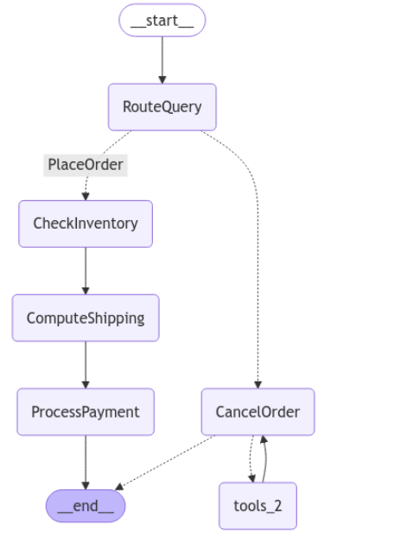
Test Queries:
- First test: “I wish to cancel order_id 223” should route to CancelOrder.
Press enter or click to view image in full size
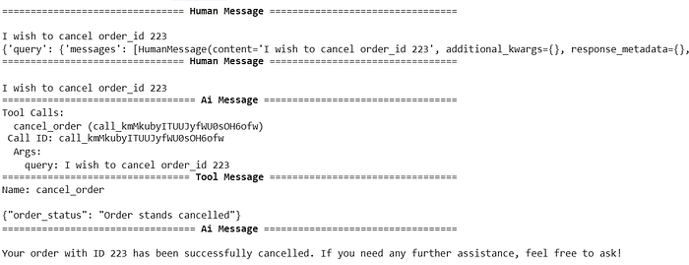
Output of first test
- Second test: “customer_id: customer_14 : I wish to place order for item_51…” should route to the place-order workflow.
Press enter or click to view image in full size
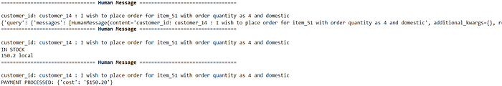
Output of second test

Conclusion:
By leveraging LangGraph, we’ve built a dynamic, branching workflow that either places or cancels orders based on user intent. We demonstrated:
- How to categorize queries with an LLM node (categorize_query).
- How to bind a tool (cancel_order) and integrate it into the workflow.
- How to check inventory, compute shipping, and process payment via separate nodes.
- How to visualize the entire workflow with Mermaid.js.
This approach is scalable: you can add more steps (e.g., address verification, promotional codes) or additional branches (e.g., update an existing order) without rewriting a monolithic script. If you need loops for retrying failed payments or verifying user confirmations, LangGraph can handle that as well.

